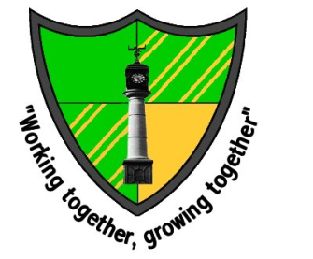
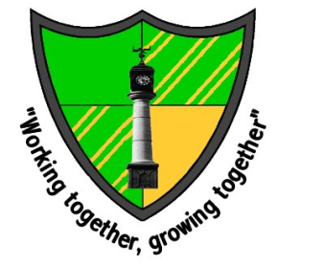
Glanhowy is a Rights Respecting School

September - Article 28 - The right to learn and go to school
October - Article 12 - The right to say what you think should happen and be listened to
November - Article 19 - The right not to be harmed and to be looked after and be kept safe
December - Article 14 - The right to follow your own religion
January - Article 29 - The right to become the best you can be
February - Article 15 - The right to meet with friends and join groups and clubs
March - Article 7 - The right to a name and nationality
April - Article 24 - The right to good food and water and to see a doctor if you are ill
May - Article 27 - The right to a good standard of living
June - Article 6 - The right to a life and to grow up to be healthy
July - Article 31 - The right to relax and play
